Appendix to Sphinx 2024-2025
Symposium in memory of Björn Kurtén on his 100th birthday
Henry Pihlström
University of Helsinki
The Paleontological Society of Finland
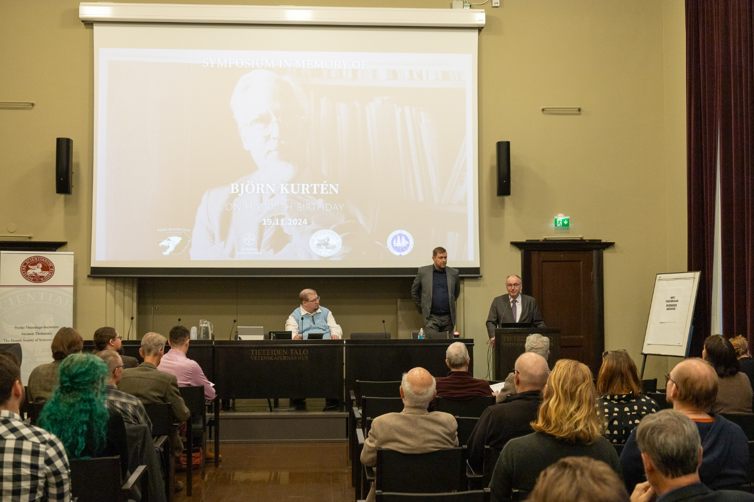

Björn Kurtén (1924–1988) is one of Finland’s most notable natural scientists of all time. In his own field, mammalian palaeontology, Kurtén’s name is still well-known worldwide. His publications continue to inspire and influence younger colleagues who have started their own careers long after Kurtén’s passing. Therefore, The Finnish Society of Sciences and Letters, The Nordenskiöld Society in Finland and The Paleontological Society of Finland BKK decided to celebrate his scientific career by arranging a symposium that represents the ‘kurténian’ heritage. The symposium was held at the House of Science and Letters in Helsinki on 19 November 2024, the day Kurtén would have turned one hundred years old. The symposium was supported partially also by The Swedish Cultural Foundation in Finland.
The symposium presentations, given by carefully selected experts from both Finland and abroad, covered a wide range of topics. Among these topics were not only scientific ones but also, for example, topics related to popularisation of science, a field that was always close to Kurtén’s heart. The invited speakers were given relatively free rein regarding the structure of their speeches. However, they were asked, in true ‘kurténian’ spirit, to keep their presentations as much as possible at a level that is understandable to non-specialists.
The symposium started at 09:00 and lasted until 17:00. It was divided into four sessions, each lasting just over an hour. The sessions were followed by a short coffee break in the morning, a lunch break in the middle of the day, and a long coffee break in the afternoon. The afternoon coffee break coincided with a poster session. All presentations were in English. Due to the relatively large number of speakers, the maximum length of an individual presentation was 20 minutes. Most speakers had planned the timing of their presentations so well that there were a few minutes left after their presentation, which offered an opportunity to take questions from the audience. There were circa 110 people in attendance at the symposium.
The first session began with introductory remarks by Henry Pihlström and Mats Gyllenberg, who represented the organisers of the symposium. In the first actual symposium presentation, Lars Werdelin gave a personal portrait of Kurtén, his former supervisor. By coincidence, only a few days before the symposium, the scientific world had been surprised by the news that a mummified cub of the Pleistocene sabre-toothed tiger Homotherium had been discovered in Siberia. This was the same species that was the titular ‘black tiger’ in Kurtén’s prehistory-themed novel Dance of the Tiger (originally Den svarta tigern, i.e. ‘the black tiger’ in Swedish), which was published in 1978. Kurtén had speculated that this particular species of sabre-toothed tiger had black fur. This newly discovered young sabre-toothed tiger cub was still covered in fur, which was indeed dark, almost black! Werdelin joked that he had known that Kurtén was very far-sighted, but not that he was apparently also a clairvoyant. The other presentations in the first session had ecomorphological themes. Jukka Jernvall discussed the substantial influence that Kurtén's many publications on the evolution of mammal teeth have had on the flourishing research field of evo-devo. Christine Janis explained how the shapes and the relative lengths of mammalian skulls are functionally related to the structure of their limbs.
The second session began with Indrė Žliobaitė's lecture on indricotheres, which were extinct relatives of the rhinoceroses, and which included some of the largest known land mammals. Taking into consideration both ecological and palaeogeographic factors, Žliobaitė discussed the theoretical population size of these giant animals in the area that today constitutes the Helsinki Metropolitan Area. Jouko Rikkinen gave a lecture on palaeobotany and what fossil amber can reveal about the coevolution of fungi and insects. Lars Werdelin (in lieu of his coauthor Mar Cabeza, who was unable to attend) gave a lecture on hyenas, an animal group that Kurtén was especially interested in, and their complex relationship with humans. John Hunter concluded the morning sessions with a lecture that returned to the topic of dental morphology, and specifically what the structure of teeth can tell us about the evolution of early primates.
The third session began with a talk by palaeoartist Maija Karala, who talked about how the progress of palaeontological science is reflected in contemporary artistic reconstructions of ancient animals. Next, Miikka Tallavaara gave a talk on the early evolutionary history of humans in East Asia. The following two talks focused on the ancient history of Finland and its surrounding areas. Kristiina Mannermaa's talk summarised the known archaeological evidence of the occurrence of wisent and aurochs in East Karelia after the end of the last glaciation. Björn Kröger talked about recently discovered Palaeozoic fossils from Lapland which are among the oldest known remains of multicellular animals found in Finland.
A poster session was held during the coffee break between the afternoon’s talk sessions. A total of 22 palaeontology- and anatomy-themed posters were presented by a combination of graduate students and established researchers. As a historical curiosity, among these posters was a contribution by Björn Kurtén himself; this contribution, titled “Great White Chark seen as prototype for Imperial Ichthyosaur”, was based on an unpublished manuscript that Kurtén had written tongue-in-cheek.
The fourth and final session began with Howie Firth's fascinating account of how Björn Kurtén, by chance, came to influence his own career. It all started when Firth happened to find a copy of Kurtén's book Dance of the Tiger in a Scottish bookstore, and the book's contents gave Firth new insights into how people belonging to so-called ‘primitive’ cultures communicate with each other in remarkably sophisticated ways. Adrian Lister talked about how deer that managed to colonise various Mediterranean islands during the Pleistocene gradually decreased in size as they adapted to the islands' special environmental conditions. Lister had studied the evolution of this size reduction by using methods that Kurtén had also applied. David Polly's lecture was an overview of the development of palaeontological science itself during the 20th and 21st centuries, that is, during and immediately after Kurtén's lifetime, and the lecture thus placed Kurtén and his scientific contributions in a wider historical context. The last lecture of the symposium was given by Mikael Fortelius, Kurtén's former student and colleague, and later his main professional successor in Finland. After a few personal reminiscences, Fortelius stated that the fact that palaeontological research in Finland today is so vibrant and so diverse is largely thanks to Kurtén’s lasting influence.
The official symposium programme concluded with the announcement of the Björn Kurtén Prize. This prize is awarded by the Nordenskiöld Society in Finland every two years. While 2024 was not technically an award year, an exception was made in honour of the 100th anniversary of Kurtén's birth. The prize, presented by Martin Lodenius, was awarded to the promising young palaeontologist Oscar Wilson, who completed his doctoral studies at the University of Helsinki.
In connection with the symposium, a special issue of the scientific journal Annales Zoologici Fennici was published. The special issue was published as both an electronic and a printed version. A small number of printed copies were available for purchase at the symposium; these were quickly sold out. The name of this special issue, Dance of the Cave Bear, refers both to the English title of Kurtén's prehistoric novel Dance of the Tiger, and to the fact that Kurtén was one of the world's foremost experts on the extinct Pleistocene cave bear. On the front of the special issue was an illustration of a bear made for Kurtén by Hubert Pepper, a Welsh artist with whom he worked closely throughout his career. In this volume were published many of the symposium presentations, and several additional contributions. Altogether the Dance of the Cave Bear volume included 28 contributions by almost 70 different authors.
Symposium programme:
9.00-9.05 Henry Pihlström & Mats Gyllenberg: Opening words
9.05-9.20 Lars Werdelin: Introducing Björn Kurtén
9.20-9.40 Jukka Jernvall: Kurtén’s contributions to evodevo
9.40-10.00 Christine Janis: A horse walks into a bar: an explanation for the long face
COFFEE BREAK
10.20-10.40 Indrė Žliobaitė: How many indricotheres could have lived in Helsinki?
10.40-11.00 Jouko Rikkinen: Interactions between insects and plants/fungi in amber
11.00-11.20 Mar Cabeza: A joint journey with hyenas
11:20-11:40 John Hunter: Are talonids more evolvable than trigonids? Evidence from North American Paleogene primates
LUNCH BREAK
13.10-13.30 Maija Karala: Palaeoart – the long dance of art and science
13.30-13.50 Miikka Tallavaara: The evolution of human niche in East Asia over the Pleistocene
13.50-14.10 Kristiina Mannermaa: Prehistoric bovids from Karelia and neighbouring areas
14.10-14.30 Björn Kröger: Unexpected findings – new data on Early Paleozoic fossils from Finland
COFFEE BREAK & POSTER SESSION
15.40-16.00 Howie Firth: Flowers for the Tiger: Kurtén’s palaeofiction
16.00-16.20 Adrian Lister: Kurténian bivariate analysis and the radiation of Mediterranean island deer
16.20-16.40 David Polly: Scaling Kurtén: the evolution of paleontology in the 20th and 21st centuries
16.40-16.55 Mikael Fortelius: Björn Kurtén’s legacy
16.55-17.00 Martin Lodenius: Björn Kurtén Prize announcement

The members of the planning group for Björn Kurtén's centenary commemoration were Ian Corfe, Mats Gyllenberg, Henry Pihlström, Janina Rannikko, Juha Saarinen, Susanna Sova, Suvi Viranta, Oscar Wilson and Indre Žliobaitė. Mikko Haaramo provided technical support during the symposium.

Link to the articles in the symposium volume: https://blogs.helsinki.fi/bk-club/bjorn-kurten-symposium-celebration/

